

SUNSHINE ACADEMY

2/22/2022

EMPLOYEE HANDBOOK

Table of Contents
Welcome page 2
Mission page 2
Vision page 2
Philosophy page 2
“AT WILL” Employment page 2
American with Disabilities Act (ADA) page 3
Employment Classification page 3
Employee Personnel Files page 3
Tuberculosis Test page 4
Employment of Relatives page 4
Probationary Status page 4
Proof of U.S. Citizenship and or Right to Work page 4
Attendance page 4
Garnishments page 5
Hours of Work page 5
Weather Related Closures page 5
Meals and Break Times/Meal Service Procedures page 5
Overtime page 5
Payday & Paychecks page 6
Performance Appraisals page 6
Termination page 6
Training and Education page 7
Employee Benefits page 7
Holidays page 7
Funeral Leave page 7
Injury Leave page 7
Jury Duty page 7
Professional Ethics page 8
Vacation page 8
Annual / Sick Leave/ Time Off/ Automatic Termination page 8
Health Insurance page 10
Accident Procedures page 10
Anti-retaliation page 10
Attire page 10
Cell Phone Policy page 11
Conduct and Disciplines page 11
Confidential Information page 11
Child Abuse & Neglect Reporting page 12
Customer Relations page 12
Drug Free Workplace page 13
Criminal Background Check/Fingerprinting Procedure page 13
Employee Problems page 13
Release of Children page 13
Gang Free Zone page 14
Emergency Evacuation Plan page 14
Sexual Harassment in the Workplace page 14
Acknowledgment of Receipt page 16

Welcome
Sunshine Academy does not discriminate against any employee or applicant because of race, color, religion, national origin, sex, age, marital status, handicap or veteran status in regard to any position for which such person is qualified. This policy covers all personnel practices, including but not limited to hiring, promotion, demotion or transfer, recruitment or recruitment advertising, layoff or termination, rate of pay or other forms of compensation, selection for training and employee benefits.

To implement this policy, Sunshine Academy will continue to:
- Recruit, hire, train, and promote person in all job classifications without regard to race, color, religion, national origin, sex, age, or handicap and to provide equal employment opportunities to disabled veterans and veterans of the Vietnam Era.
- Our company is committed to this goal. Equal Employment Opportunity is not only the law, but also it is a principle of the company operation.

Mission Statement
Building strong roots for a bright future. ™

Vision Statement
Sunshine Academy dedicates itself to providing the best possible education for our students. We believe in providing a safe and nurturing environment in which every child experiences success and growth of self-esteem.
Our children develop positive social skills and values and learn about their world through age-appropriate play, projects and activities. We provide a stable, secure, learning environment that fosters a solid foundation for lifelong success.
Philosophy
Children are born unique, creative and capable. The challenge for education is to support these strengths and abilities so that each child can grow and develop lifelong skills for problem solving, independence, curiosity, cooperation and a positive attitude for learning. Our goal is to join with families in the education of their children. Together we create a community of learners in a supportive, nurturing environment that values our diversity and celebrates our differences. Everyone has an equal right to belong and make choices and to be respected for their uniqueness.
Sunshine Academy values all people: the children in our care, their families, and our educators. Our goal is to make childhood a wonderful and rich experience for every child who enters our doors. We guide with love and understanding because one of the most important gifts we can give a child is the gift of a healthy self-esteem. We respect each child, nurture his/her spirit and embrace every culture so that every child feels included.

Contract by school year

Unless it is otherwise specified. If you are a lead teacher, your contract is by school year. Our school years start in August – July. Summer it is require just one month June and/or July. Teacher helpers can become teachers if they fill up the qualifications.

Causes that can terminated your contract: been late to work, no lessons plans on time, cellphone on the classroom, gossip, leaving children un attendance, leaving a dirty classroom.

ORGANIZATIONAL STRUCTURE

Center Directors- Directors make all the decisions for center along with the supervisor. It is her responsibility to ensure that the Center operates in full compliance of CCR licensing policies, program polices, TSR, TRS, NAEYC and Quality Rating guidelines. Directors must have a Bachelor’s, Master’s Degree or the CDA. Directors must coordinate:
- Parent – teacher communication.
- Order and cleanliness of the center.
- Ensure the center has everything it need to operate.
- Team building.
- Team relationships.
- Training the whole team on holidays or before to ensure everyone has their 30 hours required.
- Needs to be present in all the training and meetings.
- In charge of Summer Planning and class planning: making sure her team follows the curriculum.

Assistant Directors- Assistant Directors are responsible for Center activities in the Director’s absence. Assistant Directors are also classroom Teachers. They usually have a bachelor’s degree in Early Childhood Education and experience in Early Childhood settings.

Administrative Support- The Administrative Support person reports directly to the Center Director or Assistant Director. This person provides support to the Directors with regards to the administrative duties for the day-to-day operations of the Center.

Lead Teachers- Each group of children has a Lead Teacher, who has a minimum of a Child Development Associate Degree or an associate degree or higher, in Early Childhood Education along with some experience in working with that age group. Lead Teachers are responsible for programming and the overall quality of care in their area. Lead Teachers have some limited administrative duties as requested by the Director.

Teacher Assistants- Teacher Assistants are a part of the program planning and implementation in cooperation with the Lead Teacher. They will have some experience in working with young children.

All our team must be present on special days: Grandparents Day, peek-a-boo party, thanksgiving, winter festival, picture day, valentine’s day, spring festival, easter party, earth day, Mother’s Day, graduation.

Teacher Assistants are encouraged to have at least a two-year degree in Early Childhood Education or a Child Development Associate. Teacher Aides- Teacher Aides are part-time employees. They work as needed in all areas of the Center. They assist the Teachers and Teacher Assistants in the classrooms as assigned.

ALL POSITIONS

Enrollment and work need change from day to day and from season to season. To maintain State Licensing ratios and to be cost efficient staff may be assigned to different classrooms, groups, or centers, in addition hours of work or job classification may change based on program need. These re assignments will be done fairly and equitably. No employee will be guaranteed full or part-time employment or set scheduled hours of employment. Staff will be scheduled as needed between 7:30 a.m. and 5:30 p.m. In addition, employees in all positions must be able to perform the essential functions below:

ESSENTIAL FUNCTIONS
• Able to observe, see, hear and respond to children’s needs, emergencies and conflicts that might occur in a classroom, on the playground, in bathrooms and common areas.
• Able to lift 30 pounds from the floor to a waist high table 10-15 times daily.
• Able to reach a child 20-30 feet away within 30 seconds without danger to the staff person’s health.
• Able to crouch to a child’s height, maintain eye-contact at the child’s level, sit on the floor, and stand tall enough to reach children on the highest piece of equipment.
• Able to determine cognitive, social, and physical needs of children and to communicate both in writing and verbally to communicate with parents.
• Able to handle the stress, tension and exasperation that contact with many children and parents brings every day.
• Able to embrace team work and strive for excellence.
Able to be respectful and supportive of families at all levels.
• Able to communicate openly and productively.
• Able to represent the program in a professional manner both within the facility and in the community.
• Able to abide by state licensing requirements.
• Able to abide by Texas Rising Star Standards.
• Able to abide by NAEYC Code of Ethics and Statement of Commitment. See the individual job descriptions for additional requirements and expectations of each position

EMPLOYMENT POLICIES AND PROCEDURES

Employees are selected based on their qualifications to fulfill established specifications for the job. General criteria include education, experience, mental capacity, physical ability, and willingness to work in the specific environment, and ability to perform the essential functions delineated in the “Job Descriptions” section of this handbook. Statement of Policy Our program strives for each employee to be treated with respect and in a fair and just manner. In keeping with this policy, all persons will be considered for employment, promotion, or training based on qualifications without regard to race, age, handicapping condition, color, creed, sex, or national origin.

EQUAL EMPLOYMENT OPPORTUNITY

To provide equal employment and advancement opportunities to all individuals, employment decisions will be made based on merit, qualifications, availability, and ability. Our program does not discriminate in employment opportunities or practices based on race, color, religion, gender, national origin, age, physical disability, or any other characteristic protected by law. This policy governs all aspects of employment, including selection, job assignment, compensation, discipline, termination and access to benefits and training. Employees with questions or concerns about any type of discrimination in the workplace are encouraged to bring these issues to the attention of the Director.

Employees can raise concerns and make reports without fear of reprisal. Anyone found to be engaging in any type of unlawful act and/or discrimination will be subject to disciplinary action, up to and including termination of employment.

State Licensing Rules and Regulations

ALL staff must be knowledgeable in the State Childcare Licensing Rules for Child Care Centers. Failure to adhere to these policies may result in disciplinary action, up to and including termination. All staff are required to be at least 18 years of age, have a high school diploma or its equivalent, hold a degree or be pursuing a degree in Early Childhood Development. Each staff member must have current training in CPR for Infants and children, as well as First Aid with rescue breathing and choking. Each staff member in our facility must execute and submit a completed State background check as deemed by childcare regulations. If you have resided outside of the state prior to employment, documentation of a national search must be completed. State ratios are important indicators of quality. The center is required to always maintain state ratios. All staff are required to ensure that they always adhere to the state ratios. Make sure that you receive additional help when the number of children exceeds the ratio limit and make sure to coordinate when you are under ratio. With that said, leave if there are few students at the center. Your Supervisor, Director or manager can tell you.

Adherence is a dual responsibility between teachers and management. Staff must never leave their group out of ratio ensuring there is always emergency assistance available. Staff are to notify the front desk for assistance when they need to leave the group and the total number of children in attendance exceeds the state ratio

RATIO

13 kids in the whole center 1 teacher can be present

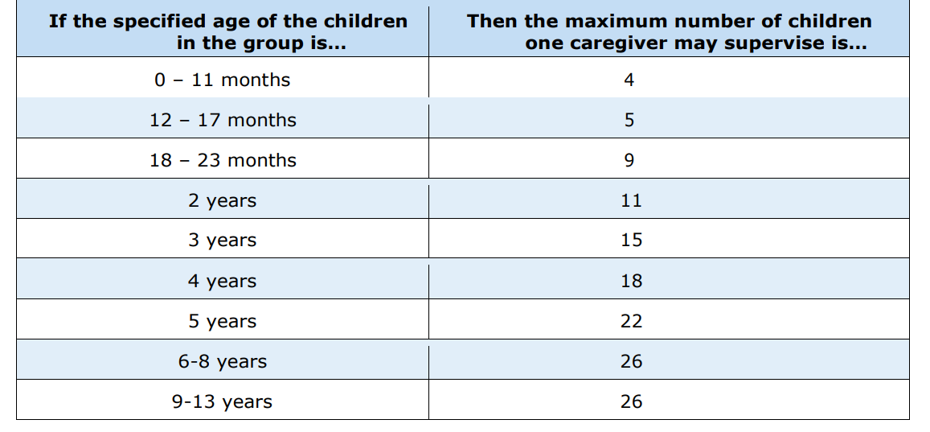

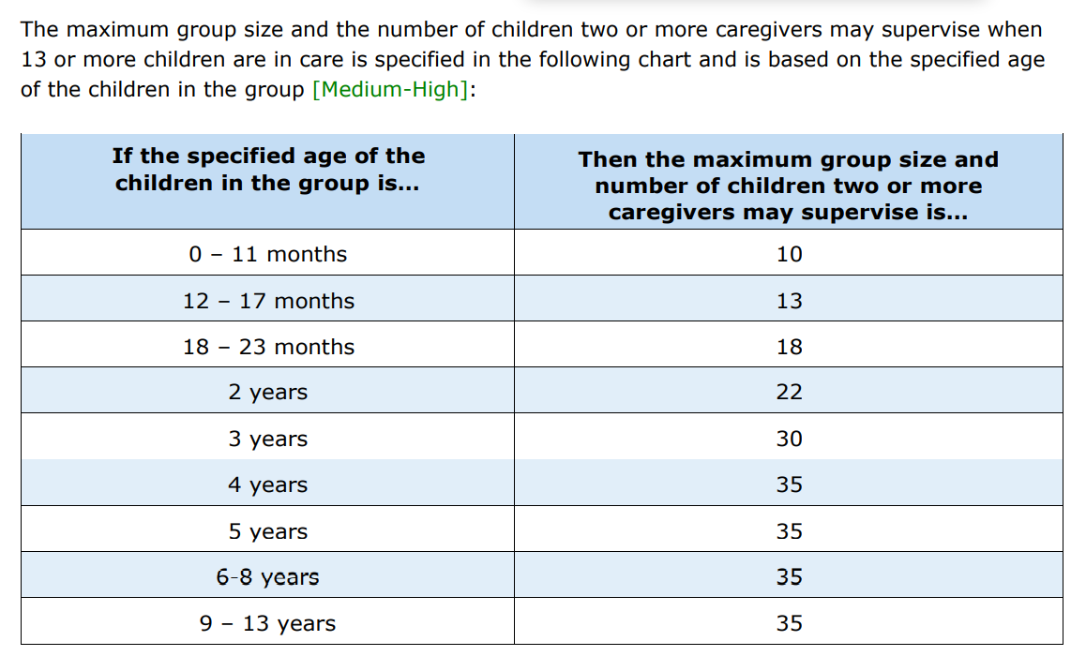

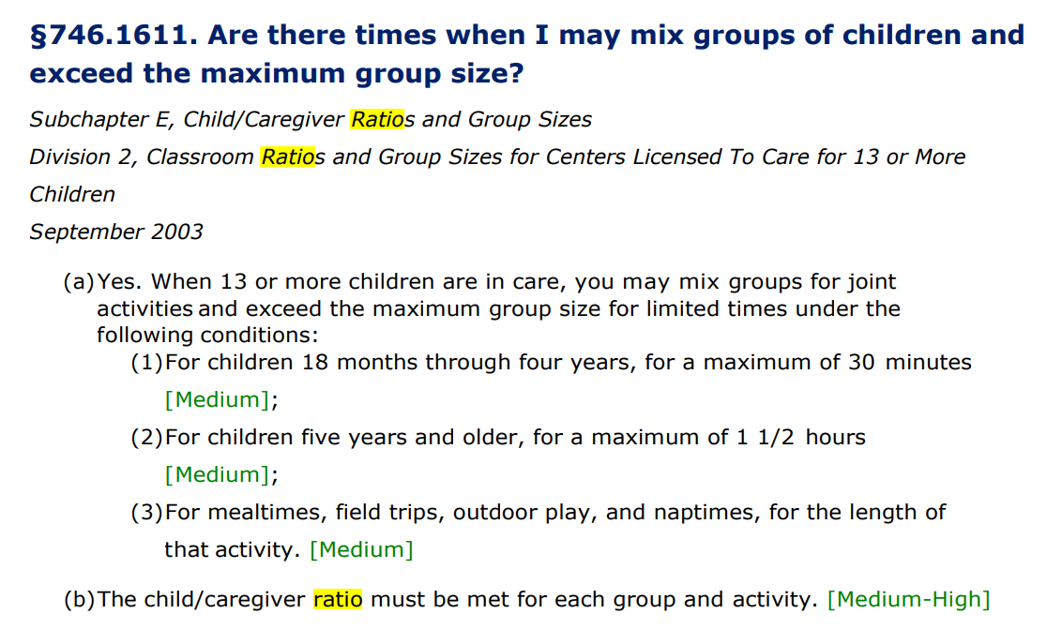
- We can reduce the number of caregivers during naptime.

“AT WILL” Employment

All employment and compensation with Sunshine Academy is “AT Will” which means that your employment can be terminated with or without cause, and with or without notice, at any time. At the option of either Sunshine Academy or at the end of the school year by yourself, except as otherwise provided.

American with Disabilities Act (ADA)
The American with Disabilities Act (ADA) requires employers to reasonably accommodate qualified individuals with disabilities. It is the policy of Sunshine Academy to comply with all federal and state laws concerning the employment of persons with disabilities.

It is the company’s policy not to discriminate against qualified individuals with disabilities in regard to application procedures, hiring, advancement, discharge, compensation, training or other terms, conditions, and privileges of employment.

Sunshine Academy will reasonably accommodate qualified individuals with a temporary or long-term disability so that they can perform the essential functions of a job.

An individual, who can be reasonably accommodated for a job without undue hardship, will be given the same consideration for that position as any other applicant.

All employees are required to comply with safety standards.

Employment Classification
At the time you are hired, you are classified as full-time, part-time or substitute (temporary) and also told whether you qualify for overtime pay.

You are informed of your job title and given a written job description. Your classification can fall in one or more of these categories. A Caregiver, Caregiver Assistance, Substitute, Nany, Janitorial, Nutrition Aide, Custodian, Director, or Assistance Director. If you are unsure of which job classification your position fits into, please ask your Director.

Full-time Employees- An employee who has successfully completed a minimum of 3 months (90 days) of employment and who works at least 40 hours per week is considered a full-time employee. Usually a Lead teacher.

Part-time Employees- An employee who works less than a 30 hours’ workweek is considered a part-time employee. Usually a teacher helper.

Temporary Employees- An employee hired for a specific period of time or for the completion of a specific project.

Substitute Employees- An employee who meets the minimum requirements and come in the absence of the Teacher or Assistant Teacher and work his/her capacity until that employee returns back to work.

Janitorial – An employee who meets the minimum requirements and come in to clean all the facility: children in the classroom (diapers), classroom, toys, restrooms, kitchen, patio, everything.

*A bad attitude to children and/or accidents may lead to the termination to your contract.

Employee Personnel Files
Personnel files are maintained for all employees and contain only employment related records. These files are kept in a secure and confidential manner.

Any and all changes should be updated as soon as a change occurs. You may request to review your own personnel file. Such request will be granted on a timely basis. You may make notes from or photocopy information in your own personnel file. Your personnel file may be reviewed only in the presence of a person selected by the owner.

What does the personal file include:

- Id
- social security
- background check: FBI check
- TB Test
- 10 hours preservice (detail)
- notes from director
- reports (warnings, absent, doctor notice, etc.)
- training
- a copy of your transcript
- Curriculum: pictures, lessons, others.

Tuberculosis Testing
All employees must be screened for tuberculosis (TB skin test or x-ray every 2 years). Employees will not be allowed to work with an expired TB test, nor will they be allowed to start their first day of work without a current TB test. It is at the expense of the employee to obtain his/her TB test.

Exemption: you can request an exemption form.

Employment of Relatives
It is the policy of the company not to discriminate in its employment and personnel actions with respect to its employee’s prospective employees and applicants. If an employee has a child in care he/she will not be able work directly with the child.

Relatives working together, we reserve the right of admitting direct relatives to work together.

Probation Status
Each new employee is hired on a probationary status for a period of 3 months (90 days) beginning on the date of hire. This period gives this company an opportunity to assess your attitude and performance before you become eligible for benefits afforded only to full-time employees. The period also gives employees the opportunity to assess the company and determine if there is a suitable match. Either party can terminate the employment arrangement for any reason during the probationary status. Sunshine Academy reserves the right to terminate employees “at will” without regard to grievance or appeal rights and without resort to any disciplinary action procedures.

Proof of U.S. Citizenship and/or Right to Work
Federal regulations require that before becoming employed, all applicants must complete and sign USCIS Form I-9, Employment Eligibility Verification, and all applicants who are hired need to present documents of identity and eligibility to work in the U.S.

Attendance
You are expected to report to work on time or 10 min. before. It is your responsibility to notify your immediate supervisor of any absences (in a letter) as far in advance of your starting time as possible. If your immediate supervisor is not available, the Assistant Director/Owner should be notified: by phone, e-mail and a letter.

Absences must be reported one week before (at least) from the beginning of your shift or normal workday. If you fail to give such notification, you will have to explain an unexcused absence.

If you are absent for three (3) consecutive days without giving the company notification, your absence may be considered a voluntary resignation (unless it is a medical emergency which prevents you from returning to work) effective the first day of the absence.

Management reserves the right to require documentation to substantiate any absence. Excessive absenteeism may lead to disciplinary action, up to and including termination of employment. Hours of employment will be scheduled in advance and provided to each employee. Schedules are subject to change as necessary.

More than three (3) tardy infractions per month will be considered excessive. Tardy infractions shall be defined as being 5 or more minutes late to the job or leaving 5 or more minutes early from the job.

If you are absent for three (3) or more days per month, your absence may be considered a voluntary resignation (unless it is a medical emergency which prevents you from returning to work) effective the first day of the absence. If you report sick any day of the week, you have to present a medical notice if not that just count as an absent.

Garnishments
We hope you will manage your financial affairs so that we will not be obligated to execute any court-ordered wage assignment or garnishment against your wages. However, whenever court-ordered deductions are to be taken from your paycheck, you will be notified. According to the Federal Wage Garnishment Act, three (3) or more Garnishment may be caused for dismissal.

Hours of work
Sunshine Academy hours of operation are from 7:30am - 5:30 pm, Monday – Friday, 12 months a year. However, changes to hours of operation can occur in order to meet customer’s demands. Employer will notify employees on a timely manner of these changes. Each employee must report to work on time. You can see our school calendar attached.

Weather Related Closures
Our facility will follow the North side Independent School District for any closures due to inclement weather. Listen to local radio or television stations for school closures.

Meals and Break Times / Meal Service Procedures

Employees:
As a full-time employee you are allowed and required to a 1-hour lunch break. As a part-time employee you are allowed and required to a 30-minute lunch break. Each employee is responsible for signing in and out daily.

Children
- Any special diet must be approved by a licensed physician and documented in the child’s folder. A special diet can only be discontinued if the child withdraws or physician amends diet through written instructions. The parent will not be permitted to amen or cancel their child’s special diet without written permission from their doctor.
- All meals are served according to the manner specified in the standards. Children are encouraged but not forced to eat. When a child eats too much or too little, the teacher is to discuss this with the parent.
- All food is properly stored, prepared, distributed and served under sanitary conditions.
- All staff and volunteers involved in the direct preparation and transportation of meals should have their hair restrained at all times.
- Meal pattern guidelines-staff are to ensure each child receives the required serving size of each food component as listed on the classroom menu. In addition, second serving of food items is available for the children.
- Feeding practices for infants and toddlers will be tailored according to each child’s nutritional needs, requirements, and schedules. Failure to adhere to these standards by any staff member will warrant disciplinary action.
- No food may be removed from the center at any time. This includes food that has been disposed, all leftovers, “scraps” or damaged food items.

Overtime
There is no overtime honored at Sunshine Academy. Payment will be made based on the agreed salary. Mandatory holidays and other periods of time-off are not considered as hours worked for overtime purposes.

Payday & Paychecks
Payroll will be processed periods are every two weeks. Pay periods are from Friday to Thursday. The owner reserves the right to change the pay periods with adequate notice. It is against company policy to discuss your pay rates amongst your co-workers. Any person caught in violation will be reprimanded accordingly.

Performance Appraisals
Performance evaluations are conducted for new employees at the completion of the Initial Employment Period of 3 months (90 days), after 6 months (180 days), and after twelve months. Employees will be evaluated on performance, attendance, punctuality, lesson plans, and interaction with children, training records, classroom organization and safety procedures. After completing their first year employment, employees are evaluated two times per year (March & September) or when there is a change of duties.

Your immediate supervisor will prepare a written evaluation of your performance and review the document with you. These evaluations will address your major accomplishments, personal progress and performance problems, if any, since the last review, and plans for improvement.

You will receive a copy of the written evaluation and must sign it to acknowledge that you have reviewed the document with your supervisor. A copy of the evaluation will be placed in your personnel file. Performance evaluations benefit the company by providing a means to improve productivity, and a channel for communication company goals and objectives.

Performance evaluation benefit you by providing information on where you stand in the view of the company, a means to increase your capabilities through an agreed upon plan for development and an opportunity for you to present your ideas regarding our and/or the company’s effectiveness.

You may disagree with your performance evaluation and file a written dissent to management. A member of management will review all dissents and determine if further action is required. The company may evaluate your performance at any time in addition to the normally scheduled date. Inadequate, substandard or poor performance may be caused for termination.

Termination
As an employee at Sunshine Academy, in the event you wish to voluntarily resign your employment with the company, you are expected to give the company adequate notice of your intentions. A minimum of one-month calendar notice is expected in writing of all employees prior to leaving at the end of the year.

When submitting the resignation letter, the letter should include the last day of work, the reason for leaving, a forwarding address, and a signature and date. Employees who are terminated for serious cause, such as drug abuse, stealing, or violence, will undergo an investigation and it will be at the discretion of the Director to pay or not to pay during the time of the investigation.

All terminating employees must return the company’s property such as laptops, keys, credit cards, documents, phones, tools, etc., prior to their last day. All employees are responsible for any missing items and will have to pay current market cost for said items.

Training and Education
Each employee is responsible to advance their knowledge and to improve their skills. All staff is required to obtain at least 24 clock hours of training per year in addition to having a current First Aid & CPR certificate on file. Those employees who have less than 2 years of experiences have an additional 24 hours pre-service.

Directors are required to have at least 30 hours of training per year.

Sunshine Academy will cover 50% of training costs, whether locally or out of town, while each employee will pay for the other 50%. First Aid and CPR certification cost is not covered by Sunshine Academy.

Employee Benefits
Sunshine Academy cares for our employees. All employees that enroll their sons and/or daughters with Sunshine will receive a special discount for our services. Please see your Director for details.

Holidays

Sunshine Academy will be closed for New Year’s Eve, New Year’s Day, Veteran’s Day, Memorial Day, Independence Day (4th of July), Labor Day, Columbus Day, the day before Thanksgiving, Thanksgiving Day, Christmas Eve and Christmas Day. Days may fluctuate, based on calendar year. Notification will be posted 48 hours in advance. Sunshine will also post an annual “School Holiday” calendar that will show which days will be closed.

Attached you can find your annual calendar.

Funeral Leave
Employees who wish to take time off due to the death of an immediate family member should notify their supervisor immediately.

Up to 3 days of bereavement leave will be allowed to all regular full time employees. However, bereavement leave is without pay.

The company defines “immediate family” as the employee’s spouse, parent, child, sibling; the employee’s spouse’s parent, child, or sibling; the employee’s child’s spouse; grandparents or grandchildren. Special consideration will also be given to any other person whose association with the employee was similar to any of the above relationships.

Injury leave
If an employee is injured at work or becomes ill in the course and scope of their duties and disqualifies for Worker’s Compensation Insurance, he/she will be able to write a letter with medical proof to the Director to request their vacation time be utilized in their absence. Without pay.

Jury Duty
As an American citizen we encourage you to fulfill your civic obligation by serving jury duty when required. Employees in an eligible classification may request up to 2 weeks of paid jury duty leave over any 1-year period. Proper documentation must be in order prior to approval.

Jury duty pay will be calculated on the employee’s base pay rate times the number of hours the employee would otherwise have worked on the day of absence. Employee classifications that qualify for paid jury duty leave are both regular full-time and regular part-time employees.

Professional Ethics
Sunshine Academy will operate by the following code of ethics. Each employee is held to this standard as part of his, her job requirements.
- The employee will respect and promote the unique identity of employee, child and family, and refrain from stereotyping on the basis of gender, race, ethnicity, culture, religion, or disability. It is the policy of Sunshine Academy that all employees shall treat all colleagues and parents without discrimination. Evidence of discrimination will be documented and may lead to disciplinary action, up to and including termination of employment.
- The employee must be familiar with the ethnic background and heritage of families in the program and must be able to serve and effectively communicate, to the fullest extent feasible, with children and families with no or limited English proficiency.
- The employee will follow the chain of command. Owner> Supervisor > Director > Te
- The employee will maintain good relations with others.
- The employee will respect the privacy and dignity of others.
- The employees will be courteous at all times in dealing with children, their families, volunteers, and his/her fellow employees.
- The employee’s conduct and standard of dress should also be favorable to public opinion.
- The employee shall treat colleagues with the utmost respect, and at all times act so as to support rather than to obstruct colleagues in fulfilling their responsibilities. Employees shall assume responsibility for sharing pertinent knowledge with their colleagues, treating respectfully their difference of opinion and expressing any complaints or dissatisfaction to one’s immediate supervisor so as not to create dissension among fellow employees by airing difference of opinion and dissatisfaction to persons other than the immediate supervisor.
- The employee shall conduct him/herself in such a manner as to enhance the creditability of Sunshine Academy. Our goal is to show the community that Sunshine Academy has loyal, well-trained and dedicated staff members.
- No visitors on-site without proper approval from Director.

Vacation
Vacation time off is not available during the regular days and time of operation however eligible employees who have been with the company for more than year can use all our holidays. This time is to provide opportunities for rest, relaxation, and personal pursuits. All regular full-time employees are eligible to earn and use vacation time for Christmas as described in this policy. Temporary staff and substitutes are exempt. A full time employee will receive 5 working days of pay (40 hours) during the time that Sunshine Academy is closed. After two years of full time employment. No vacations will be granted during normal days of operation. Days off will include month in which we will not open and any other School Holiday as defined by each Calendar made available by Sunshine.

Annual Leave/ Sick Leave/ Time off/ Automatic Termination
No annual and sick leave is offered in the first year. All time taken off must receive prior approval and it is unpaid time.

Employees must call the night before prior to assigned work period and request Sick Leave from their supervisor. If the Director is not available, the employee may speak to the Assistant Director or Owner. If time is taken off for self or his/her child, a doctor’s notice will be needed. If not is just consider an absent. More than 3 absents without receipt in a semester automatically terminates their employment at Sunshine Academy.

If employee would like to switch their shift with a co-worker, the Director/Owner would have to approve it prior to switch. An employee absents for 3 consecutive days without notice automatically terminates their employment at Sunshine Academy.

After 1st year of employment, an employee can accumulate 1 sick day per quarter (every 4 months) not to exceed 3 days total. All hours must be utilized before their anniversary date. If hours are not used, they are lost. No cash or accumulations of days are allowed. Doctor’s notice will be needed to receive compensation.

Sick days are without pay.

Health Insurance
Ask to your supervisor to know about the programs that we offer.

Accident Procedure
All employees must report any injury and/or accidents to his or her supervisor immediately. Have a written notice (kinderlime) take a screen shot send it immediately by text to your Supervisor 956.740.0522. Text must be send with your ipad.

Anti-Retaliation Policy
Sunshine Academy strictly prohibits retaliation against any person by another employee or by the company for using the company complaint procedure, reporting harassment, or for filing, testifying, assisting or participating in any manner in any investigation, proceeding or hearing conducted by the company or a governmental enforcement agency or for filing a Worker’s Compensation claim. Additionally, the company will not knowingly permit any retaliation against any employee who complains of prohibited harassment or who participates in an investigation. Prohibited retaliation includes, but is not limited to, termination, demotion, suspension, failure to hire or consider for hire, failure to give equal consideration in making employment decisions, failure to make employment recommendations impartially, adversely affecting working conditions, or otherwise denying any employment benefits.

The company does not consider conduct in violation of this policy to be within the course and scope of employment and does not sanction such conduct on the part of any employee, including management employees.

Attire
The following dress code is acceptable: uniform polo and black bottoms. Black treasures for Monday – Thursday and dark colored blue jeans no faded (Fridays), washed look or tatter jeans are allowed. Daily grooming, and personal cleanliness standards contribute to the morale of all employees and students and affect the business image Sunshine Academy presents to all visitors.

During business hours or when representing the company, you are expected to present a clean, neat, and tasteful appearance. You should dress and groom yourself according to the requirement of your position and accepted social standards. This is particularly true when your job involves dealing with students and visitors in person. You are allowed to wear black bottoms Monday through Thursday and blue jeans on Friday.

If your supervisor feels your personal appearance is inappropriate, you may be asked to leave the workplace until you are properly dressed or groomed. Under such circumstance, you will not be compensated for the time away from work. Consult your supervisor if you have questions as to what constitutes appropriate appearance.

Without unduly restricting individual tastes, the following personal appearance guidelines should be followed:
- No cut off clothing, shorts, or sleeveless shirts, mini shorts, miniskirts, tank tops, tube or halter tops, may not be worn under any circumstances.
- Hickeys and tattoos do not present an appropriate professional appearance and should not be visible.
- Shoes must provide safe, secure footing, and offer protection against hazards. Sandals and flip-flops are not allowed.
- Offensive body odor and poor personal hygiene is not professionally acceptable.
- Excessive make up, facial jewelry, such as eyebrow rings, nose rings, lip rings, cheek rings, tongue studs, is not professionally appropriate and must not be worn during business hours.
- Torso body piercings with visible jewelry or jewelry that can be seen through or under clothing must not be worn during business hours.
- Failure or refusal to follow the appearance code or safety requirements will be a basis for disciplinary actions, which could include counseling, warning, suspension, or termination.

Cell phone policy
Sunshine Academy has a no cell phone use in effect. You may use the office phone in the following situations:
- Emergencies.
- On your break.
- For contacting parents in cases of emergencies or parent conferences, etc. (The center Director will call parents to communicate if anything happens). Any other usage of the office phone must be approved by supervisor, on your lunch or brake.

Cellphone use is just allowed in our lobby or outside Sunshine (NO classroom, no restrooms).

No cellphones inside classrooms at anytime.

Conduct and Disciplines
You are expected to conduct yourself in accordance with the company’s guidelines, procedures, practices and generally accepted business behavior. The company, in turn, will treat you with honesty and fairness.

If you exhibit behavior not acceptable to the company, disciplinary action may result. Your overall work record and length of service will be considered before determining a course of action. Also, infractions of certain guidelines, procedures and practices are more serious than other; therefore, each situation is weighed individually.

For infractions that do not merit drastic action, you may receive both verbal and written warnings and time-off. Employees can be put on three-day suspension without pay. Available vacation days cannot be taken in conjunction with disciplinary suspensions.

Warnings are given with the intent of motivating employees to act in acceptable way in the future. They are also designed to protect the safety and to ensure the fair treatment of all employees.

Confidential Information
Any proprietary information concerning the business affairs of our parents, employees must be held confidential. As a condition of employment, all company employees agree not to disclose or otherwise misappropriate confidential information during or after the termination of their employment with the company.

- Employees should not remove confidential information from the company premises and should return all confidential information to the Director upon termination.
- All official information for the news media concerning Sunshine Academy and or its employees shall be released only through the office of the Director/Owner, unless otherwise authorized.
- Any act in violation of the provisions shall be grounds for dismissals from Sunshine Academy.

Child Abuse & Neglect Reporting
Reporting Process
The law requires that any person who has caused to believe or suspects the likelihood of abuse or neglect or that has concerns regarding the welfare of a child must report it within 48 hours. A person who reports child abuse or neglect in good faith is immune from either civil or criminal liability. Upon listening to the child’s report of abuse or neglect the Outcry witness to call the TDPFS and its Child Protective Services at 1-800-252-5400.
Staff Action Process
- The provisions of these procedures apply to all staff working within the development facility: direct care staff, custodial food service, and clerical and management staff.
- Upon notification of a child abuse allegation against an employee, the allegation will be reported to the TDPFS.
- The employee will be immediately informed of the allegation by the Owner/Director.
- Sunshine Academy will do everything possible to maintain the minimum standards during the investigation, which may include temporary suspension of the employee until investigating is complete and a decision is made by TDPFS.

The following are some Do’s and Don’ts to keep in mind after a child has made a disclosure of abuse and during the process of investigation and intervention:

Do’s
- Allow the child to use his/her own words to describe the incident.
- Assure the child that he/she is not to blame for what happened.
- Treat the child normally.
- Take care of the child’s emotional needs.
- Listen carefully and take notes.
- Allow the child to talk about the incident if he/she brings it up.
- Write down concerns and questions for TDPFS, CPS, police officers, and therapist.
- Support the child.
- Reassure that nothing bad is going to happen to them for telling of the incident, praise the child for being brave “you did good by telling me what happened”.

Don’ts
- Use your language to help the child describe what happened.
- Try to investigate.
- Overreact.
- Express fear, anger and/or anxiety.
- Initiate conversation about the incidents.
- Let personal feelings influence the child.
- Reward the child for giving information.
- Ask “why” questions to the children.

Customer Relations
The success of Sunshine Academy depends upon the quality of the relationships between our parents, co-employees, our suppliers and the public. Here are several things you can do to help give our parents a good impression:

Act competently and deal with the parents and children with a courteous and respectful manner and communicate pleasantly with other employees at all times.
Follow up on orders and questions promptly, provide businesslike responses to inquiries, request, and perform all duties in an orderly manner. Take pride in your work and enjoy doing your very best.

Drug Free Workplace
Sunshine Academy is a Drug Free/Alcohol Free workplace. Smoking is not permitted on the premises.

Criminal Background Check / Fingerprinting Procedure
All employees at Sunshine Academy are required to have a criminal background check and finger printing done before hired. Any employee with a criminal offense doesn’t necessarily mean you are disqualified to work at Sunshine Academy. Each case is at the discretion of the Owner/Director and Licensing.

Employee Problems & Written Complaints / Automatic Dismissal
The company recognizes the value of providing a way for job related problems and complaints to be reviewed and resolved fairly and as quickly as possible. Supervisors have a responsibility to be sensitive to and aware of your problems and complaints.

You have a responsibility to be sensitive to and aware of the operating needs and requirement of the company. If you have a problem or complaint about your job, you are encouraged to discuss it with your supervisor. Ideally, your problem should be resolved between yourself and your supervisor.

If you and your supervisor cannot resolve the issue, a member of management should become involved until a resolution is reached. All complaints and request of mediations should be within 3 days of complaint.

No tolerance for stealing, abuse of a child, sexual conduct with any party of the organization, exploitation of a child, or sexual abuse or mistreatment of any child, or amongst your co-workers, administration or parent.

Procedures for Release of Children
Children will only be released to a parent or designated adult 18 years or older by the parent in writing. Persons authorized to pick up the child must provide a valid Driver’s License or a valid Identification Card at the time of drop off and release. A child will not be released into the custody of an unauthorized adult, unless consent forms have been signed by the parent.

The Minimum Standards for Child-Care Centers provided by the Texas Department of Family and Protective Services Licensing Division is our basic guideline. Please read and follow all guidelines included in this document. Failure to follow the standards will result to remedial actions.

Gang Free Zone
Be aware that according to Texas Penal Code, any area within 1,000 feet of a childcare center is a gang-free zone, where criminal offenses related to organized criminal activity are subject to harsher penalty.

Emergency Preparation Plan
Sunshine Academy has an emergency preparation plan in case of a tornado, flood or hurricane, health events such as medical emergencies, communicable disease outbreak, and human caused events such as intruder with weapons, explosion, or chemical spills. We will evacuate to our nearest gym. Staff and children will walk to the designated safe area until their parents/guardians arrive. An emergency evacuation and relocation diagram is posted in each classroom. As the caregiver evacuate to the designated area, he/she will be responsible to have the sign-in sheet, attendance sheet, emergency contact information for each child, and a list of emergency numbers in their possession. We will use cellular phones or two-way radios to communicate and alert for help. We will have an emergency kit prepared with the necessities to feed, care and keep the children comfortable until help arrives.

Sexual Harassment in the Workplace
Sunshine Academy is committed to providing a work environment that is free from all forms of discrimination and conduct that can be considered harassing, coercive, or disruptive, including sexual harassment. Actions, words, jokes, or comments based on an individual's sex, race, color, national origin, age, religion, disability, sexual orientation, or any other legally protected characteristic will not be tolerated.
Sexual harassment is defined as unwanted sexual advances, or visual, verbal, or physical conduct of a sexual nature. This definition includes many forms of offensive behavior and includes gender-based harassment of a person of the same sex as the harasser. The following is a partial list of sexual harassment examples:
* Unwanted sexual advances.
* Offering employment benefits in exchange for sexual favors.
* Making or threatening reprisals after a negative response to sexual advances.
* Visual conduct that includes leering, making sexual gestures, or displaying of sexually suggestive objects or pictures, cartoons or posters.
* Verbal conduct that includes making or using derogatory comments, epithets, slurs, or jokes.
* Verbal sexual advances or propositions.
* Verbal abuse of a sexual nature, graphic verbal commentaries about an individual's body, sexually degrading words used to describe an individual, or suggestive or obscene letters, notes, or invitations.
* Physical conduct that includes touching, assaulting, or impeding or blocking movements.
*Unwelcome sexual advances (either verbal or physical), requests for sexual favors, and other verbal or physical conduct of a sexual nature constitute sexual harassment when:
(1) submission to such conduct is made either explicitly or implicitly a term or condition of employment,
(2) submission or rejection of the conduct is used as a basis for making
employment decisions, or
(3) the conduct has the purpose or effect of interfering with work performance or creating an intimidating, hostile, or offensive work environment. If you experience or witness sexual or other unlawful harassment in the workplace, report it immediately to your supervisor. If the supervisor is unavailable or you believe it would be inappropriate to contact that person, you should immediately contact the Director/Owner or any other member of management. You can raise concerns and make reports without fear of reprisal or retaliation.
All allegations of sexual harassment will be quickly and discreetly investigated. To the extent possible, your confidentiality and that of any witnesses and the alleged harasser will be protected against unnecessary disclosure. When the investigation is completed, you will be informed of the outcome of the investigation. Any supervisor or manager who becomes aware of possible sexual or other unlawful harassment must immediately advise the Business Manager or any member of management so it can be investigated in a timely and confidential manner. Anyone engaging in sexual or other unlawful harassment will be subject to disciplinary action, up to and including termination of employment.

Acknowledgment and Consent

This receipt acknowledges that you have received a copy of the employee handbook August 2018 – July 2019 and will adhere to all the policies and procedures listed.

PLEASE READ, INITIAL, SIGN AND DATE THE LAST PAGE OF THIS HANDBOOK AND RETURN IT TO THE DIRECTOR.

- I have read and understand this handbook of the policies & procedures.
I also understand that this is a legally-binding contract valid for this coming school year. ______
- I agree to abide by all policies and procedures listed. ______
- I understand that changes can and will be made at any time with notice. ______
- I will report any and all changes in writing to the Director. ______
- If I agree to follow all stipulation outline in this handbook. Failure to follow procedures could jeopardize my work. ______
- I agree to come to work in my hours with a great attitude respect my chain of command, respect my co- workers. ______
- I agree to come prepare to class and send my lessons plan on time. __________
- I know and understand than more than 3 absents in the semester may lead to the termination of my contract. _____________
- I do understand If I have one absent or tardy per week, I won’t be able to get a bonus. __________
- I do understand that I need to follow my schedule (not before or after clock in / out). _________
- I du understand that I need to follow the instructions given by my supervisor, director, manager. _______
- I understand that this is a legal contract and can be used against me in a court of law. ____

Employee print: _______________________________________________Date: ___________

Employee signature: __________________________________________ Date: ___________

Director’s signature: ___________________________________________Date: ___________

Owner signature: ______________________________________________Date: ___________

